**NFTA Metro Amherst-Buffalo Transit Options**

**Study Status Report**

**September 15, 2014**

# Introduction

The purpose of this report is to serve as a summary of work that has been completed to date and to advise you on progress made since November 2013. It provides an overview of the remaining alternatives to be detailed in Tier 2 and an outline of the immediate next steps.

## Project Purpose & Need

The purpose of the proposed project is to provide a fast, reliable, safe, and convenient transit ride in the Amherst-Buffalo Corridor linking established and emerging activity centers along the existing Metro Rail Line in the City of Buffalo with existing and emerging activity centers in the Town of Amherst. The project is intended to serve increased travel demand, support redevelopment and other economic development opportunities, provide high-quality transit service to and from key activity centers in the Corridor, and better serve transit-dependent population segments.

# Study Process Overview

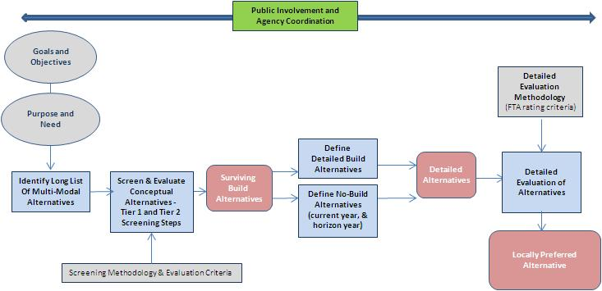

We are here

## Progress to Date

* Continuous collaboration with local committees (two meetings to date)
  + Project Steering Committee (Key NFTA staff and state and federal agency representatives) – kick off and discussion of issues, opportunities, and ideas for the initial long list of alternatives, and presentation of the Tier I Results (long list screening)
  + Project Advisory Committee (key local government, institutional, employer, and community stakeholders group) – kick off and discussion of issues, opportunities, and ideas for the initial long list of alternatives, and presentation of the Tier I Results (long list screening)
* Individual meetings with Elected Officials and other key stakeholders, as well as outreach at community events – ongoing
* Established a Project Website: <http://to.nfta.com/>
* Conducted first set of Public “Open House” Workshops in November 2013
* Developed a draft Purpose and Need Statement for the study
* Developed draft screening & evaluation methodology that was applied to the Long List of Alternatives
* Identified Long List of Alternatives
* Conducted screening of Long List of Alternatives for fatal flaws (Tier 1 Analysis)
* Reviewed and identified ridership forecasting approach then met with Federal Transit Administration to discuss (STOPS model)
* Scheduled second Elected Officials Briefing – September 23rd
* Scheduled second Public Outreach meeting – to be held September 30th
* Developed and scheduled a University at Buffalo On-Board Passenger Survey - October 2014
* Developed Criteria for and Preliminary Station and Stop Locations
* Completed Existing and Future Conditions No Build Report
* Initiated development of Tier 2 Alternatives (see next steps)

# Long List of Alternatives – Overview

The Long List of Alternatives was developed to consider the universe of options for enhancing transit in the study area. These alternatives were then grouped by type and potential location for ease of evaluation. These groups included:

Options by Type

* Light-Rail Transit (LRT): Using special rail vehicles, this system operates on a track within a protected rail right-of-way or within the existing street system. LRT can have street-level, elevated, or underground platforms for passenger access.
* Modern Streetcar: This mode consists of low speed, low floor rail vehicles that operate along streets to provide circulation for passengers. Power is provided by overhead electric power typically know as catenary power. Vehicles are developed for easy on, easy off operation. Operations consist of frequent stops, to provide circulation for passengers typically in an urban setting. Convenience, versus speed or schedule reliability is typical for this type of mode.
* Bus Rapid Transit (BRT): Using conventional buses or special BRT buses, this system operates with vehicles that receive priority to move faster than general traffic, including movement through controlled intersections. Vehicles use permanent weather-protected designated stops with passenger amenities and wayfinding information
* Preferential Bus Service: Includes limited elements of the BRT system with an improved service plan for operations including intersection enhancements and improved stops.
* Enhanced Bus operations: This would include limited improvements to the bus route system and frequency of service, including some express buses making fewer stops along some routes to decrease travel time between some destinations.

Options by Route

* Light Rail Transit (LRT) Alternatives –using Bailey Avenue, or Millersport Highway, or Niagara Falls Blvd
* Bus Rapid Transit (BRT) Alternatives –using Bailey Avenue, or Millersport Highway or Niagara Falls Blvd
* Modern Streetcar – along Bailey Avenue
* Tonawanda Turnout – an abandoned railroad right-of-way that has a potential connection with the existing rail system, but is outside of the project study area
* Bus Alternatives – Varied routes (see below)
  + Preferential Bus
  + Enhanced Bus

These options by route are shown in the following summary graphics, with the exception of the Modern Streetcar route and Tonawanda Turnout. These alternatives were eliminated from further consideration in the Long List screening process because they did not serve the project’s Purpose and Need or were not reasonable as compared to other alternatives under consideration.

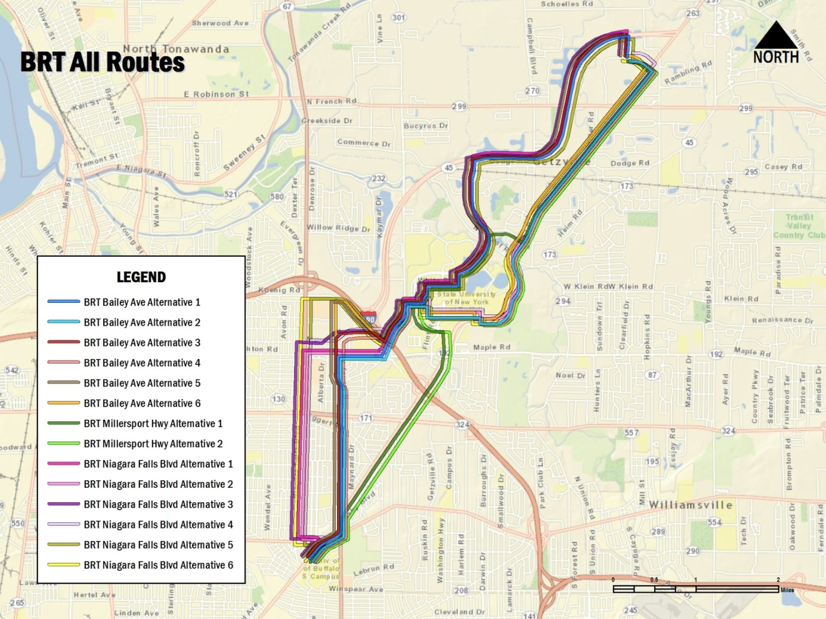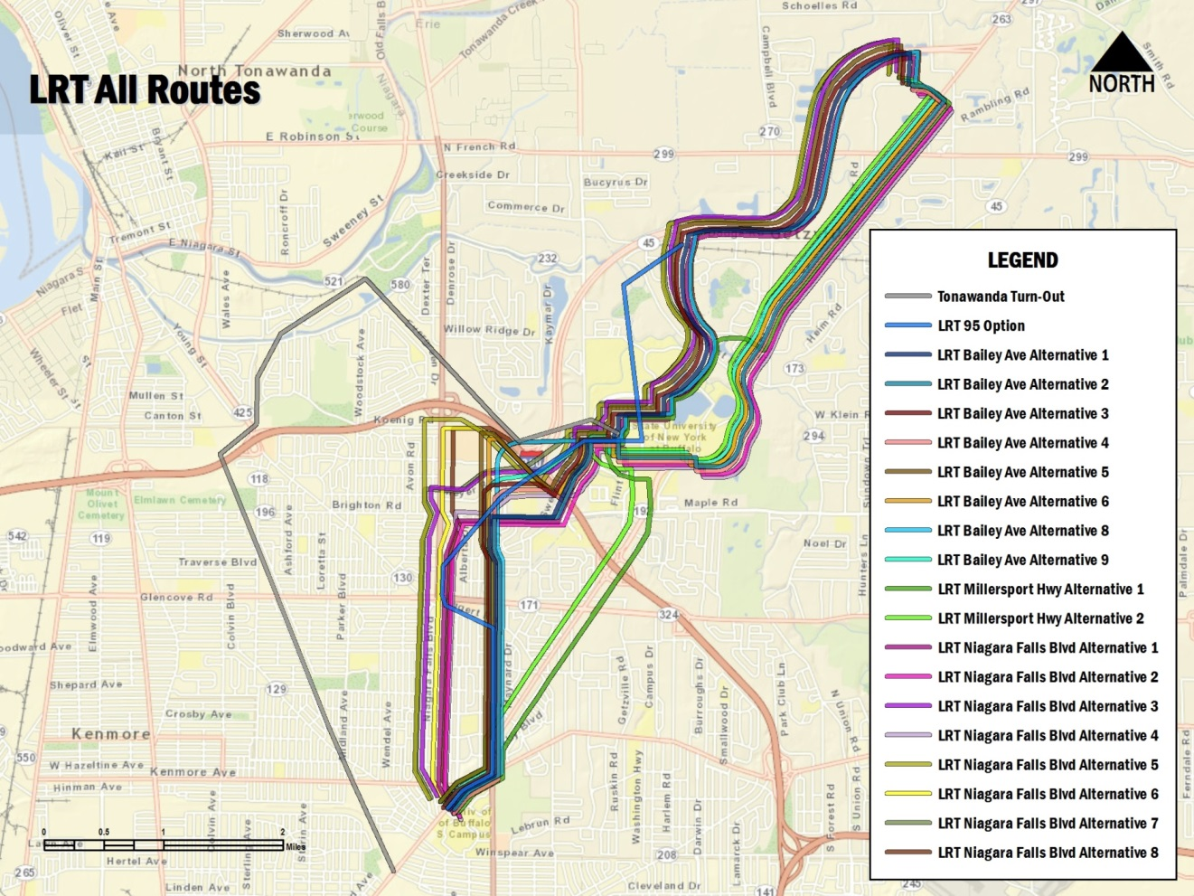

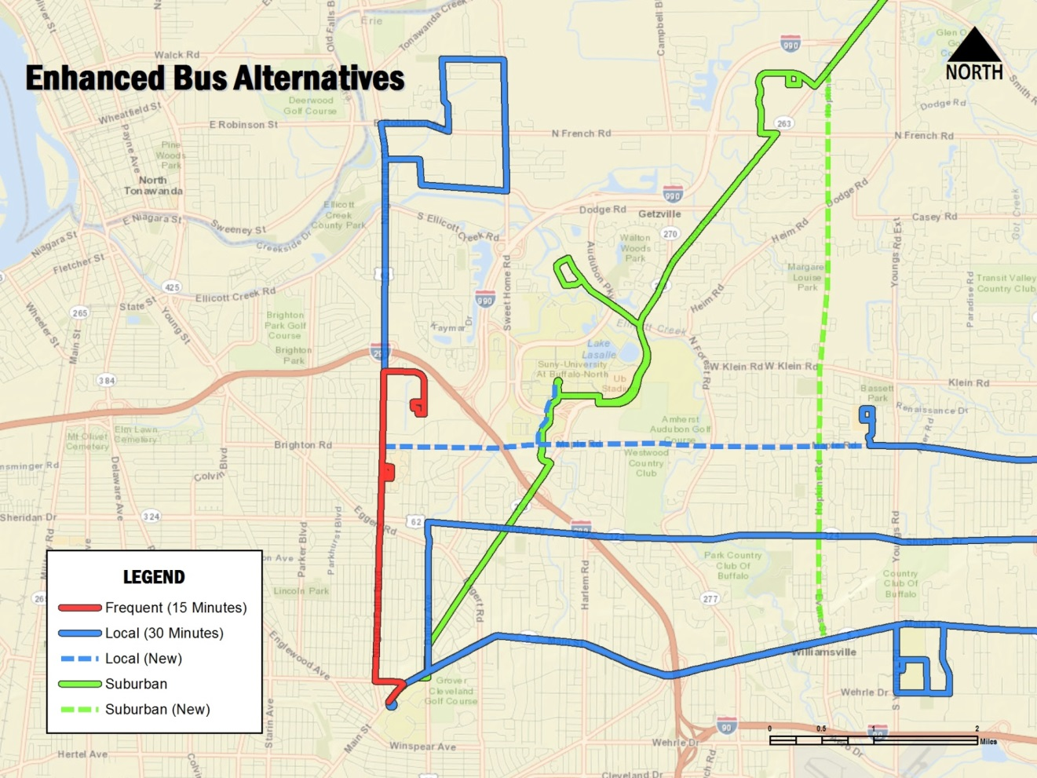

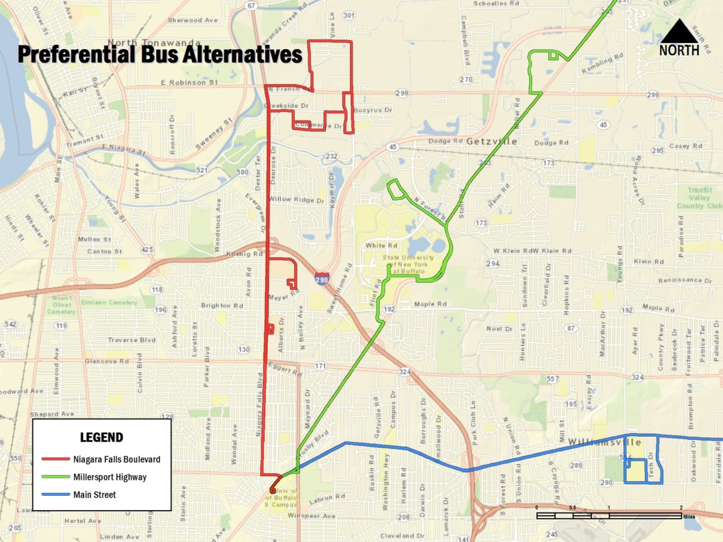

# 

# Alternatives Advancing to Tier 2

The findings of the Tier 1 evaluation for the LRT and BRT options by route are shown in the tables below. The results are color-coded as follows:

* Green – Alternatives which pass the test for meeting the three criteria of (1) serving the purpose and need, (2) reasonableness, and (3) no fatal flaws
* Yellow – Alternatives which are feasible but which have some complications – do not meet all three criteria
* Red – Alternatives which do not meet two or more of the criteria

The Preferential Bus and Enhanced Bus alternatives were found to meet all of the screening criteria, therefore, will advance to Tier 2 for further analysis.

**LRT SCREENING RESULTS**

|  |  |  |  |
| --- | --- | --- | --- |
| **Long List Alternative** | **Does the Alternative Meet Purpose & Need** | **Sufficiency of ROW/Land Area Assessed (Reasonableness Test 1)** | **Complex Structures, Exceeds Vehicle Maximum Grades, Curve Radii, Operational Flaws (Reasonableness Test 2)** |
| **LRT Alternatives** | | | |
| ***Niagara Falls Boulevard*** | | | |
| **1** | yes | sufficient; but narrow ROW on Bailey Avenue | no for subset alignment; Kenmore Road curve radii fail |
| **2** | yes | sufficient; but narrow ROW on Bailey Avenue | no for subset alignment; Kenmore Road curve radii fail |
| **3** | yes | sufficient; but narrow ROW on Bailey Avenue | complex structure 1-290 interchange & utility corridor |
| **4** | yes | sufficient; but narrow ROW on Bailey Avenue | complex structure 1-290 interchange & utility corridor |
| **5** | yes | sufficient; but narrow ROW on Bailey Avenue | complex structure 1-290 interchange & utility corridor |
| **6** | yes | sufficient; but narrow ROW on Bailey Avenue | complex structure 1-290 interchange & utility corridor |
| **7** | yes | sufficient; but need to acquire substantial property outside of ROW | elevate utility corridor lines/poles or tunnel under |
| **8** | yes | insufficient space to come to grade out of I-990 tunnel | complex, extraordinarily high structure over utility corridor adjacent to tunnel under I-990 |
| ***Bailey Avenue*** | | | |
| **1** | yes | sufficient; but narrow ROW on Bailey Avenue | no |
| **2** | yes | sufficient; but narrow ROW on Bailey Avenue | no |
| **3** | yes | sufficient; but narrow ROW on Bailey Avenue | complex structure 1-290 interchange & utility corridor |
| **4** | yes | sufficient; but narrow ROW on Bailey Avenue | complex structure 1-290 interchange & utility corridor |
| **5** | yes | sufficient; but narrow ROW on Bailey Avenue | complex structure 1-290 interchange & utility corridor |
| **6** | yes | sufficient; but narrow ROW on Bailey Avenue | complex structure 1-290 interchange & utility corridor |
| **7 (LRT 95 Option)** | yes | narrow ROW on Bailey Avenue and utilizes extensive land outside ROW | multiple complex structures |
| **8** | yes | insufficient space between North Bailey and I-290 interchange to make grade changes | complex, extraordinarily high structure 1-290 interchange & utility corridor or tunnel |
| **9** | yes | insufficient space to come to grade out of I-990 tunnel | complex, extraordinarily high structure over utility corridor adjacent to tunnel under I-990 |
| ***Millersport Highway*** | | | |
| **1** | yes | sufficient | no |
| **2** | yes | sufficient | no |
| ***Tonawanda Turnout*** | | | |
| **1** | no, outside study area | N/A | N/A |

**BRT SCREENING RESULTS**

|  |  |  |  |
| --- | --- | --- | --- |
| **Long List Alternative** | **Does the Alternative Meet Purpose & Need** | **Sufficiency of ROW/Land Area Assessed (Reasonableness Test 1)** | **Complex Structures, Exceeds Vehicle Maximum Grades, Curve Radii, Operational Flaws (Reasonableness Test 2)** |
| **BRT Alternatives** | | | |
| ***Niagara Falls Boulevard*** | | | |
| **1** | yes | sufficient | no |
| **2** | yes | sufficient | no |
| **3** | yes | sufficient | complex structure 1-290 interchange & utility corridor |
| **4** | yes | sufficient | complex structure 1-290 interchange & utility corridor |
| **5** | yes | sufficient | complex structure 1-290 interchange & utility corridor |
| **6** | yes | sufficient | complex structure 1-290 interchange & utility corridor |
| ***Bailey Avenue*** | | | |
| **1** | yes | sufficient | no |
| **2** | yes | sufficient | no |
| **3** | yes | sufficient | complex structure 1-290 interchange & utility corridor |
| **4** | yes | sufficient | complex structure 1-290 interchange & utility corridor |
| **5** | yes | sufficient | complex structure 1-290 interchange & utility corridor |
| **6** | yes | sufficient | complex structure 1-290 interchange & utility corridor |
| ***Millersport Highway*** | | | |
| **1** | yes | sufficient | no |
| **2** | yes | sufficient | no |
| ***Bailey Avenue Modern Streetcar*** | | | |
| **1** | no; circulator service with low speeds and short distances between stops | N/A | N/A |

Based on the Tier 1 screening process, the following alternatives are recommended for further analysis in Tier 2. The remaining alternatives will be presented to the public on September 30th and are shown below (please note that the Enhanced and Preferential Bus Alternatives are the same as shown on page 5 of this document).

* Niagara Falls Boulevard LRT and BRT Alternatives 1 & 2 (using Bailey Avenue subset alignment for LRT)
* Niagara Falls Boulevard LRT Segment Alternative 7
* Bailey Avenue LRT and BRT Alternatives 1 & 2
* Millersport Highway LRT and BRT Alternatives 1 & 2
* Enhanced Bus Alternatives
* Preferential Bus Alternatives

The following alternatives are recommended to be dropped from further consideration

* Tonawanda Turnout
* Bailey Avenue Modern Streetcar
* Niagara Falls Boulevard LRT Alternatives 1 & 2 (original Kenmore Avenue alignment)
* Niagara Falls Boulevard LRT and BRT Alternatives 3-6 and LRT Alternative 9
* Bailey Avenue LRT and BRT Alternatives 3-6 and LRT Segment Alternatives 8-9
* Bailey Avenue LRT Alternative 7 (1995/Citizens for Regional Transit alignment)

# 

# 

# 

# 

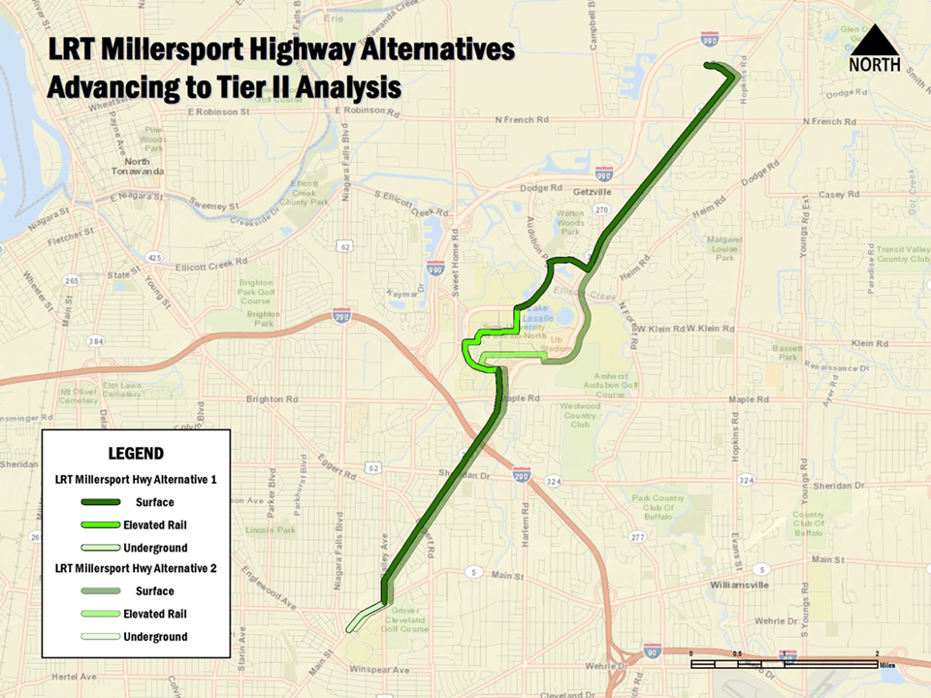

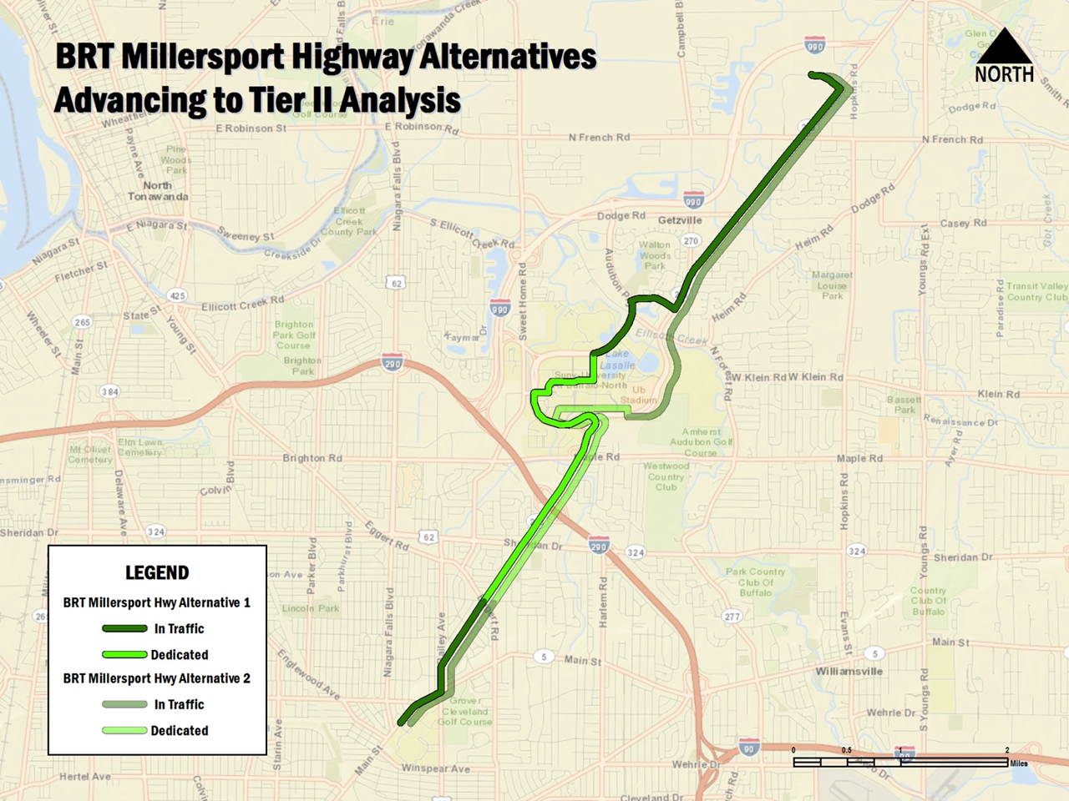

# Next Steps

The immediate next steps in the study process include the specific tasks listed below:

* **Hold Public Outreach Open House Meeting**
  + September 30, 2014 from 4:00 pm to 8:00 pm
  + Allen Hall, Room 100, University at Buffalo South Campus
  + 3435 Main Street, Buffalo NY
* **Conduct University at Buffalo Bus Passenger Survey**
  + October 2014
* **Develop Tier 2 Alternatives – (Currently underway)**
  + Develop conceptual service plan, running times, station locations, parking
  + Develop ridership estimates using an FTA approved methodology: STOPS
  + Develop order of magnitude capital cost
  + Identify existing social and environmental conditions
* **Conduct Tier 2 Screening of Alternatives**